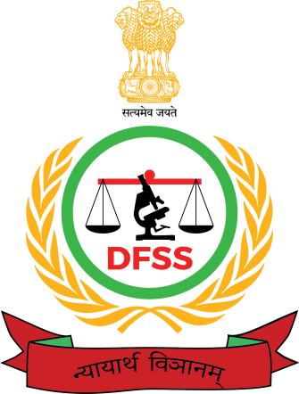

REPORT ON THE PARTICIPATION & REPRESENTATION OF INDIA
IN THE “3RD INTERNATIONAL SCIENTIFIC AND PRACTICAL CONFERENCE, “FORENSIC EXAMINATION : THEORY AND PRACTICE IN THE MODERN WORLD”
MINSK, BELARUS, APRIL 26-27, 2023

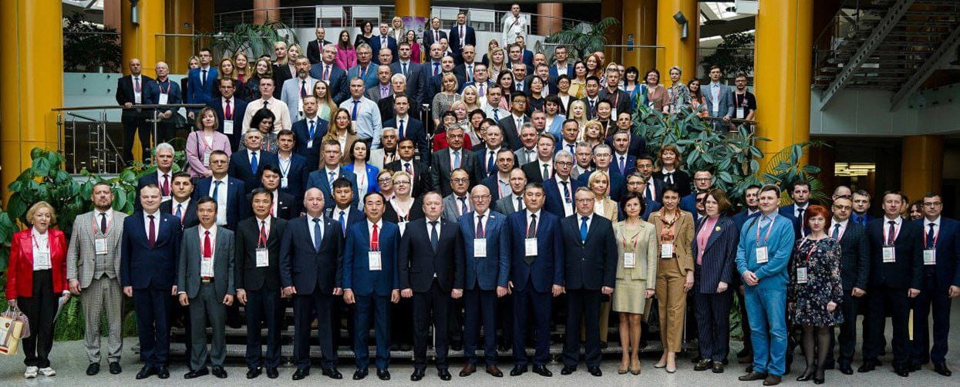

GOVERNMENT OF INDIA,
MINISTRY OF HOME AFFAIRS
DIRECTORATE OF FORENSIC SCIENCE SERVICES
Block No. 9, 8th Floor, CGO Complex, New Delhi 110003
Tel No. 011-24362676 Fax No. 011-24362819
Email: cfs-dfss@nic.in DFSS website: www.dfs.nic.in

- As per MHA letters No. MHA/25013/12/2021-WS-III Dated 31st March 2023 and 25020/17/2023-WS-III Dated April 23, 2023 an Indian forensic expert team was deputed to participate in the “3rd International Scientific & Practical Conference, “Forensic Examination: Theory And Practice In The Modern World” Minsk, Republic Of Belarus, April 26-27, 2023. The team comprised of the Chief Forensic Scientist, DFSS, MHA, GOI New Delhi along with a senior expert.

Indian Forensic Delegation:
- Dr. Sanjay Kumar Jain, Director-cum-Chief Forensic Scientist, DFSS, MHA, GOI Delhi,
- Dr. Deepak Middha, Dy. Director & Scientist D, CFSL, DFSS, MHA, GOI Chandigarh,
- The nominated Indian forensic delegation participated & represented India in this International event.
- The Indian forensic delegation was received at Minsk Airport, Republic of Belarus by the representatives from the Indian Embassy at Minsk and the State Forensic Examination Committee of the Republic of Belarus on 25th April, 2023 AN. The accommodation for both the above officers was arranged by Indian Embassy at Minsk, Belarus.
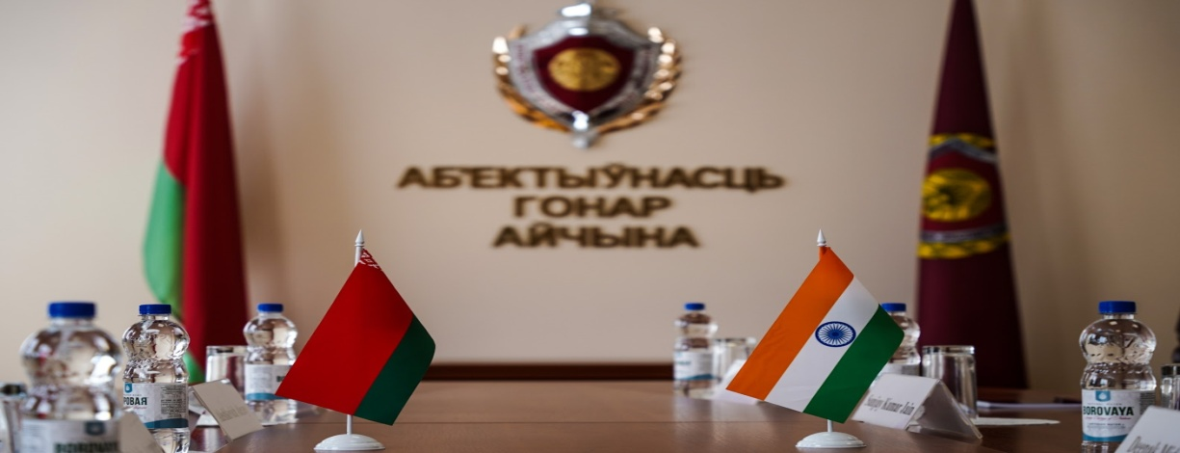
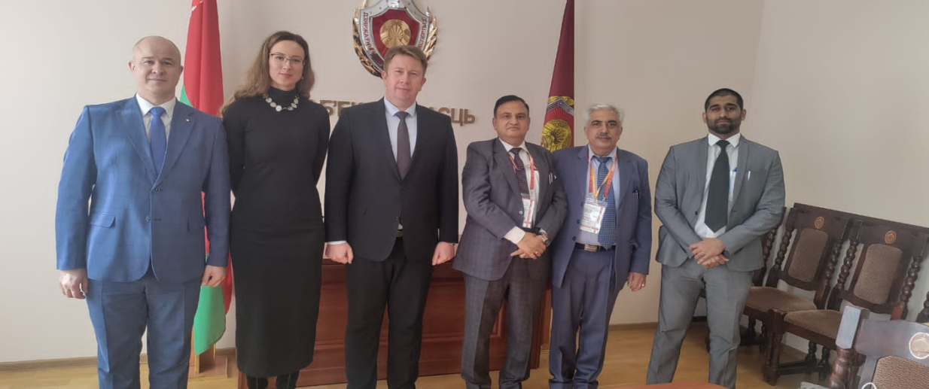
Senior office bearers of the State Forensic Examination Committee of the Republic of Belarus welcoming the Indian side represented by the Director cum Chief Forensic Scientist, Directorate of Forensic Science Services, Ministry of Home Affairs, Government of India in the International Forensic Conference, April 26-27, 2023, at Minsk, Belarus.

Objective of the forensic visit:

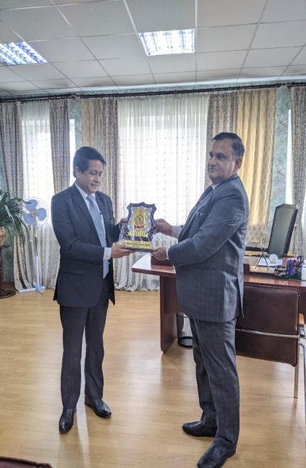
- Delegation stayed at Minsk, Republic of Belarus during 25.04.2023 to 28.04.2023. The inaugural session was held on 26th April, 2023 morning in the National Library of Belarus. During the lunch breaks the delegation had meetings with the Hon’ble Indian Ambassador Sir on 26th and 27th April, 2023.
- Hon’ble Ambassador got the inputs from Dr Sanjay Kumar Jain, the Director cum Chief Forensic Scientist, Govt. of India. CFS, apprised about the Republic of Belarus bilateral cooperation offer aimed to bilaterally strengthen the Forensic Science Services within the ambit of mutual foreign relations.
- Hon’ble Ambassador expressed India’s concern & requested the Indian delegation to progress with all sincerity. Dr. S K Jain, Chief Forensic Scientist presented a Memento from DFSS side to the Hon’ble Ambassador of India at Minsk and appraised that Indian participation in this international forensic event would be a step forward to aid and promote mutual trust. It may also mutually promote the justice delivery process "through the bilateral strengthening exercise in the forensic science services".

On 27th April, 2023 in the sectional meeting Dr S K Jain, on behalf of the Government of India heartily greeted all international delegates participating there in the International Conference. Dr. Jain presented DFSS brochure to Sh.Mozheiko Alexandar, Head of the Criminalistics Division and Head of the Ballistics Division, State Forensic Examination Committee, Republic of Belarus and thanked the Belarusian side for extending their services to strengthen forensic science services bilaterally | 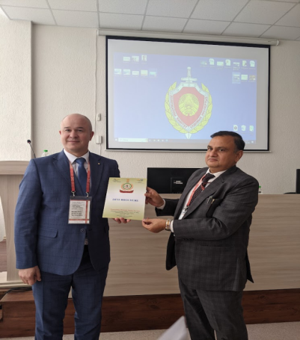
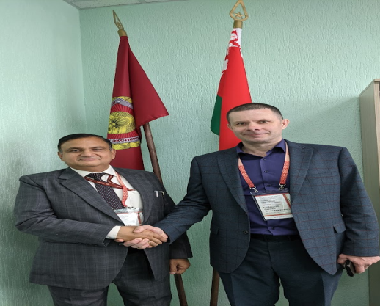 | 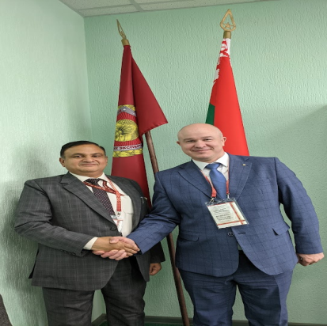

- This international conference by the Belarusian side is an effort to ponder upon upcoming futuristic multi type challenges posed by technical advances in crime tactics versus forensic investigative mechanisms in the modern world.

- This conference gave a glimpse of forensic setup, technological advances vis’ a vis’ challenges faced in the forensic investigations by the participating nations.

- It gave a scientific platform to interact, learn, review, introspect the needs to strengthen forensic examination and investigation services to respond to upcoming challenges

- The State Forensic Examination Committee of the Republic of Belarus also arranged the display of some latest forensic tools, kits and instruments.  - The presentations and the technical display of newer and upcoming tools to address the modern world challenges were taken note of in relevance to India.  - Technology updations were taken note of in relevance to India.  - The participating scientists had brief discussions on the upcoming challenges in forensic investigations during question sessions and during the breaks. | 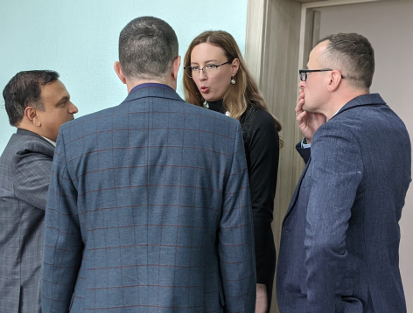  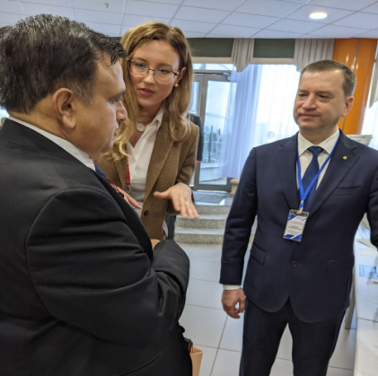

On 27th April, 2023 evening the Dy. Chairman of the State Forensic Examination Committee (SFEC) of the Republic of Belarus, Sh. Aleshkevich Alexey along with Sh, Mozheiko Alexander & Mrs. Ksenia Belyanko from Belarusian International Cooperation had an exclusive meeting, discussion of the cooperation issues in the central office building with the Indian Forensic Delegation headed by Dr. S. K. Jain, accompanied by Dr Deepak Middha and Sh. Jaysundhar D, First Secretary/ Head of Chancery Embassy of India, Minsk.
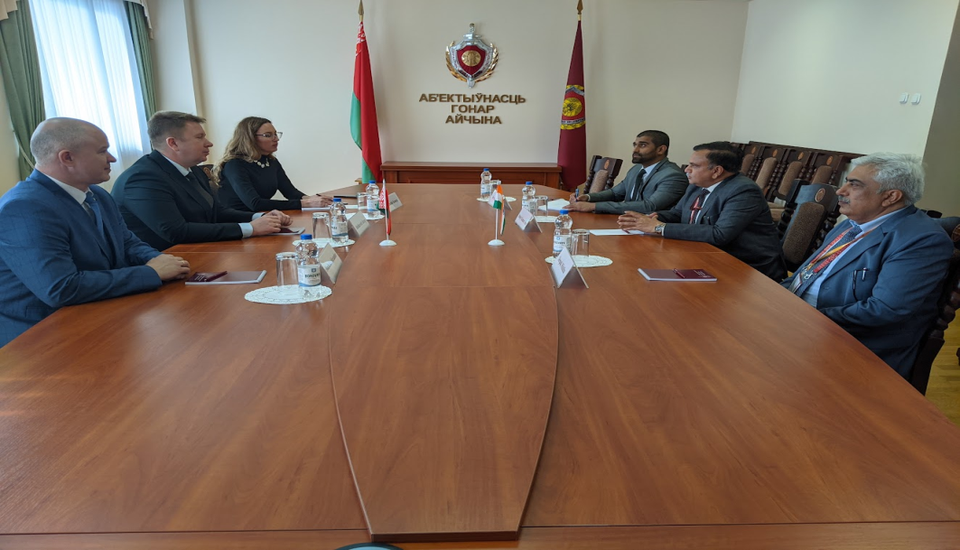

- The SFEC chairperson on the Belarusian side briefed about the Forensic setup at Republic of Belarus. SFEC of the Republic of Belarus was established in accordance with the Decree of the President of the Republic of Belarus dated April 22, 2013. The Day of the Forensic Expert is celebrated in the Republic of Belarus annually in the month of April. The State Forensic Examination Committee of the Republic of Belarus was established on the basis of expert agencies and departments of the Internal affairs bodies under the State Medical Forensic Examination Service within the purview of the Ministry of Justice, Ministry of Emergency Situations & the Ministry of Defense.

- Dr. S K Jain briefed about Indian forensic set-up (Central & State level) special efforts made by Govt of India to strengthen the Forensic Setup in India at par with International standards.
- Dr. Jain also proposed to render the forensic help from the Indian side to redress the gap areas in forensic setup in Belarus through the bilateral ties between India-Belarus ministries in the upcoming future. He further stressed to use forensic science expertise to handle the modern and newer crime tactics developing at pace globally especially to deal with the global mentors of narcotics and cyber crimes.
- The SFEC chairperson on the Belarusian side briefed that the main tasks of the State Committee are: Implementation of a Unified State Policy in the Field of Forensic Science; Implementation of Forensic Expert Activities; Determination & Implementation of the Main Directions of Improvement of Forensic Expert Activity, Introduction into Practice of Achievements of Science & Technology, Progressive Forms & Methods Of Organizing & Conducting of Expert Research; Organizing Training and Education of Persons Intending to Carry Out (Carrying Out) Forensic Expert Activities, etc.
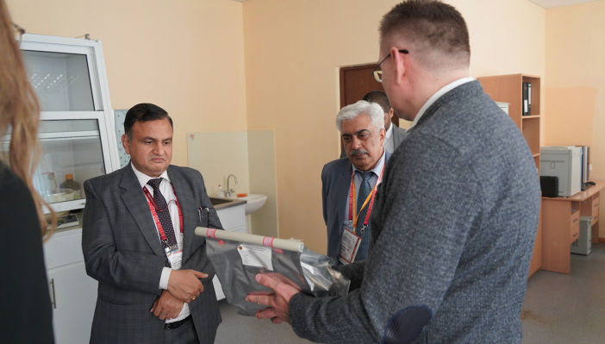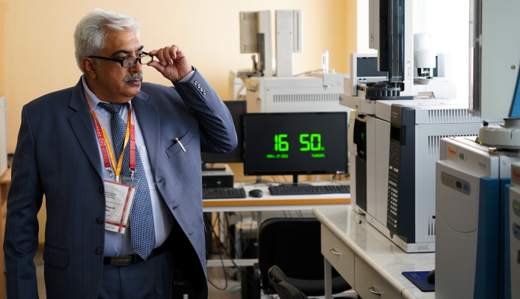

- After the meeting the SFEC chairperson on the Belarusian side led the Indian expert delegation along with the representative from the Indian embassy to their forensic laboratory. Indian delegates had scientific interactions with the scientists working there. The meeting lasted with vote of thanks and exchange of souvenirs.
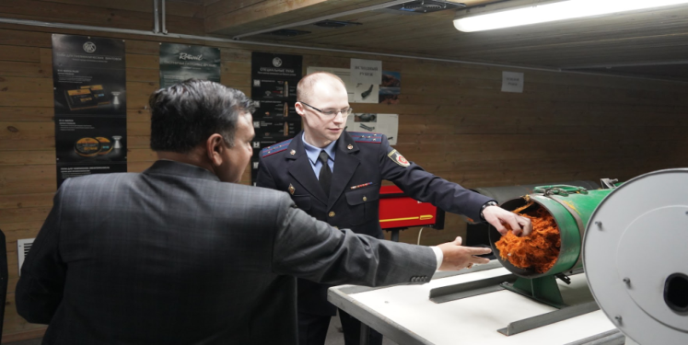
On 28th April, 2023 the Indian forensic delegation paid their homage at the museum of the Great Patriotic War, Minsk, Republic of Belarus
Expectations/ Outcome of such bilateral international events:
Such efforts are long term beneficial to the participating nations. It explored the possibilities of having mutual ties to strengthen forensic science services. It's certainly a way to step forward to tackle global crime with certainty; especially the situations, where the mentor of crime is not present in the country or continent "where a crime in series has been committed".
*******

